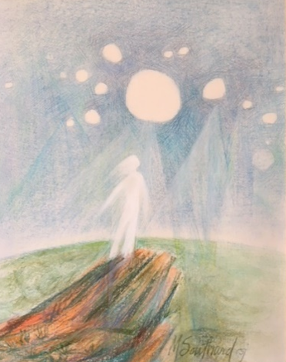

Chapter Planning Committee

Small Group Communal Discernment
Calling Forth Sisters for Elected Leadership
Come to the edge

Find a quiet place where the group can pray and share undisturbed for approximately one to two hours depending on the size and sharing of the group.

Communal discernment can be done in person or by ZOOM. Remember communal discernment is a mutual sharing of the fruit of one’s personal discernment and listening attentively to the Spirit speaking in and through one another.
You may want to bring with you to this discernment process: Considerations in Discerning Elected Leadership (included in the discernment packet) and some paper to write the names of those Sisters who others suggest they would call forth for elected leadership.

Scripture Reflection:
“In the same way, the Spirit too comes to the aid of our weakness; for we do not know how to pray as we ought, but the Spirit itself intercedes with inexpressible groanings. And the one who searches hearts knows what is the intention of the Spirit, because it intercedes for the holy ones according to God’s will.” (Romans 8:26-29)

Opening Prayer: O God, Source of Goodness and Light, we thank you for bringing us together. Pour Your Spirit upon us. Open our minds and hearts. Give us the courage to share honestly and humbly the fruits of our personal discernment. Enable us to listen attentively not only to the words but to each person’s heart as they share. Give us the interior freedom to prayerfully and honestly consider each Sister who is named. Enable us to reverence each woman’s gifts and abilities. We ask for interior freedom, that will enable us to move beyond our own predilections and be fully open to the promptings of the Spirit in ourselves and in each other. Let us allow ourselves to be influenced by the grace which flows from each women’s personal discernment. Let us hold each Sister named in our love.

Repeat process below (individual sharing and communal response) until each person in the group has named all those Sisters whose names surfaced during her personal discernment.
Individual Sharing
Each person, when ready, shares the fruit of their personal discernment. Each person names one Sister who surfaced in her personal discernment and identifies the gifts and abilities she sees in the Sister. Suggested format: “I am putting forth (Sister’s name) for leadership because I see the following qualities in her (name qualities) that will enable her to fulfill the responsibilities of the CLT for the next 5 years.

Communal Response
After each sharing, the group enters into a few moments of silence. Then each member of the group is invited to affirm or name additional gifts or abilities that the Sister named has for leadership. If a member of the group does not know the person named or cannot affirm them for whatever reason, she may remain silent.
Take a few minutes of quiet after all in the group have shared. Is there any other Sister’s name that someone wants to surface?

Closing Prayer
Hold again each Sister who has been named in God’s love and the love within your own heart. Pray quietly for each Sister named.

Pray Together: Spirit of God, we ask that you give us your insight, wisdom, kindness, compassion as we continue to move though the discernment process for elected leadership. We pray for all those who have been named and ask that you guide and lead them in their own discernment process. Give us the interior freedom and love for the common good. Spirit of Wisdom, thank you for moving among us during our gathering. As we leave may we be aware that You accompany us on our journey and we ask You to guide our Congregation during this sacred time of Chapter preparation. Amen.

After you have completed your personal and communal discernment, please complete the “Calling Forth for Elected Leadership” form included in your discernment packet for each Sister you wish to call forth to elected leadership. You may call forth no more than 10 Sisters. Forms are due by January 20, 2023. Return forms to The Chapter Planning Committee, c/o Jackie Skrypek at The LaGrange Park Center, 1515 West Ogden Avenue La Grange Park, Illinois 60526.

